**EES Methodology Template**

Use this template as a guide to setting out your methodology in EES. Every bold heading should be one accordion in your methodology. Make use of subtitles within each accordion to make it easier for your users to navigate.

EES methodologies are living documents, that will be updated each year you publish on EES. Moving away from a single publication:single methodology approach means users can easily see how methodologies have changed over time, and holds us to account as statisticians to explain any changes and how these affect comparisons with historic data.

Within each section, make it clear in subheadings when different methodology was applied, e.g.:

**Data collection**

**School census 2018 – current**

*Details on current methodology to sit under this subheading*

**Old survey 2015-2017**

*Details on old methodology from 2015 -2017 to sit under this subheading*

**Background**

Use this section to give an overview of the methodology. It is the first accordion your users will see, so needs to contain the essentials.

* What has changed from the last release?
* Have there been any policy changes that might affect the data? You should flag this in your content but can go into more detail here.
* Are there any common misconceptions with your data? Explain the truth here

**Data collection**

Use this section to explain where your data comes from.

* Where is the data from, can you link to the source?
* When is data collected? How long is the gap between this and publication, and why is this the case?
* How has collection changed over time?
* Are there plans to change the collection before your next publication?

**Data processing**

Use this section to explain how you get from source data to final output

* Which datasets do you link to? How good are your match rates?
* Are there any cleaning steps?
* How are you using reproducible analytical pipelines as part of your processing? What steps are automated?
* If your code is available on GitHub, you can share a link to the repository. Get in contact with us if you want to mirror your Azure Devops code onto GitHub for transparency.

**Data quality**Use this section to explain how you validate your data, and to assure users of its quality.

* What do you do to quality assure your data?
* Have any results been identified as outliers/duplicates? How have these been treated?
* What are your rules for rounding and suppression, and why have these been applied? Are calculations based on rounded or unrounded figures?
* What steps have been taken to protect confidentiality of individual-level data?
* How have you checked for consistency between related releases?

**Strengths and limitations**

Use this section to explain to your users how your data should be used.

* How [accurate/reliable](https://www.ons.gov.uk/methodology/methodologytopicsandstatisticalconcepts/uncertaintyandhowwemeasureit) is the data? You can talk about sample sizes, standard errors, confidence intervals and statistical significance here.
* Any further information on caveats used in your content

**NATIONAL STATISTICS ONLY:**

**National Statistics**

National Statistics are required to include a short section on major developments since the assessment report that designated the publication as National Statistics. This should include information on additional breakdowns or data included to meet new user needs, e.g.:

* Major changes to methodology, data sources or data collection
* Major changes to the structure of the publication or the commentary
* Changes to the timing of the publication or combining publications (other than one-off changes due to issues or resource)
* Information on any de-designations and re-assessments

Where large changes have been made, provide a summary and a link to further information in documentation published at the time.

The focus of this section should be about how these changes have continued compliance with the Code of Practice by:

* Increasing trustworthiness of the statistics by improving data security or confidentiality
* Improving quality through data validation, using methods consistent with latest academic developments, identifying new data sources, improving data collections, or adapting to changes in existing sources
* Increasing value by adapting the content of the publication to changing user needs, conducting user engagement, increasing accessibility, improving quality of commentary to make the statistics easier to understand

**You might also be interested in**

* Link to other publications that have crossover with your release.

**Annexes**

* Calculations - how do you calculate your measures? What are the numerators and denominators used? Use formulas instead of wordy explanations e.g., of using formulas in the exclusions methodology:

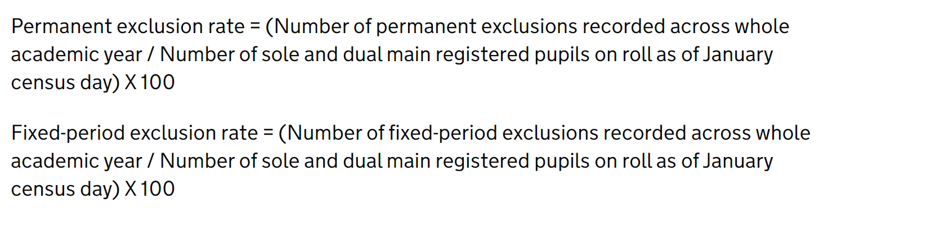

* Content that changes with every release (e.g., reporting the weightings for survey data) can be held here. This gives the user a consistent place to look for this information and means you do not need to edit the main content of the methodology.
* Any large supporting tables can go in an accordion in your annex, and you can refer to the relevant section in the annex in your methodology if needed.

Any definitions should go in our [EES glossary](https://explore-education-statistics.service.gov.uk/glossary) – you can easily link definitions into your content by moving definitions over. Get in touch with us at [statistics.DEVELOPMENT@education.gov.uk](mailto:statistics.DEVELOPMENT@education.gov.uk) for more information.